**UNIVERSITY OF ENGINEERING AND TECHNOLOGY, PESHAWAR PAKISTAN**

*Main Campus*



**Web Technologies (Lab)**

**Assignment/Lab Task No. 01**

**Submitted By**

|  |  |
| --- | --- |
| **Name:** | **Hazrat Bilal** |
| **Registration No.** | **24PWBCS1345** |
| **Semester:** | **4th Semester, BS Computer Science** |
| **Section:** | **E** |
| **Submission Date:** | **25th February 2026** |

**Submitted To**

**Sir Muhammad**

DEPARTMENT OF COMPUTER SCIENCE

UNIVERSITY OF ENGINEERING AND TECHNOLOGY, PESHAWAR, PAKISTAN

**Task 1: Creating an HTML File**

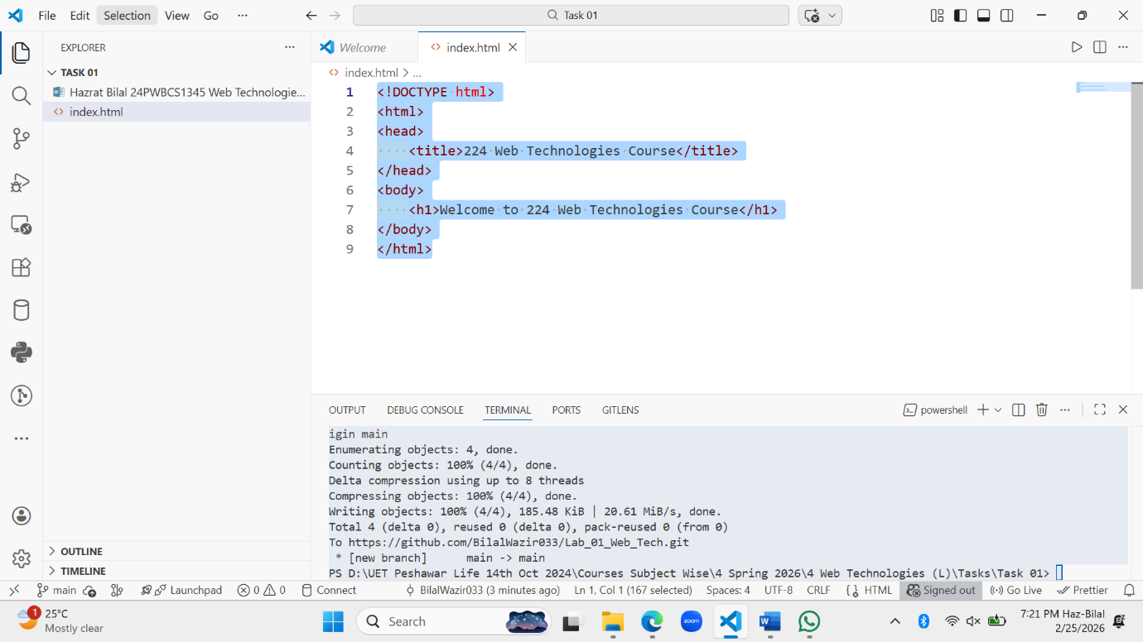

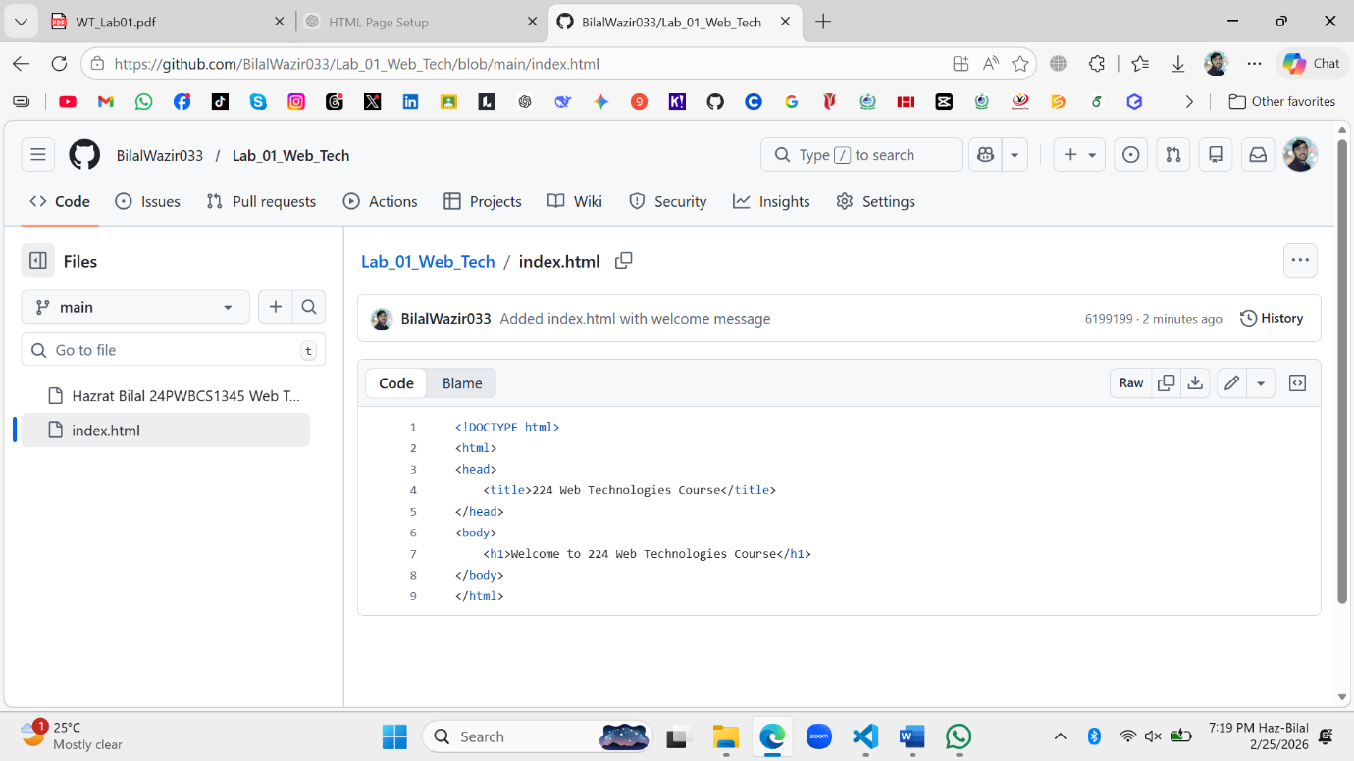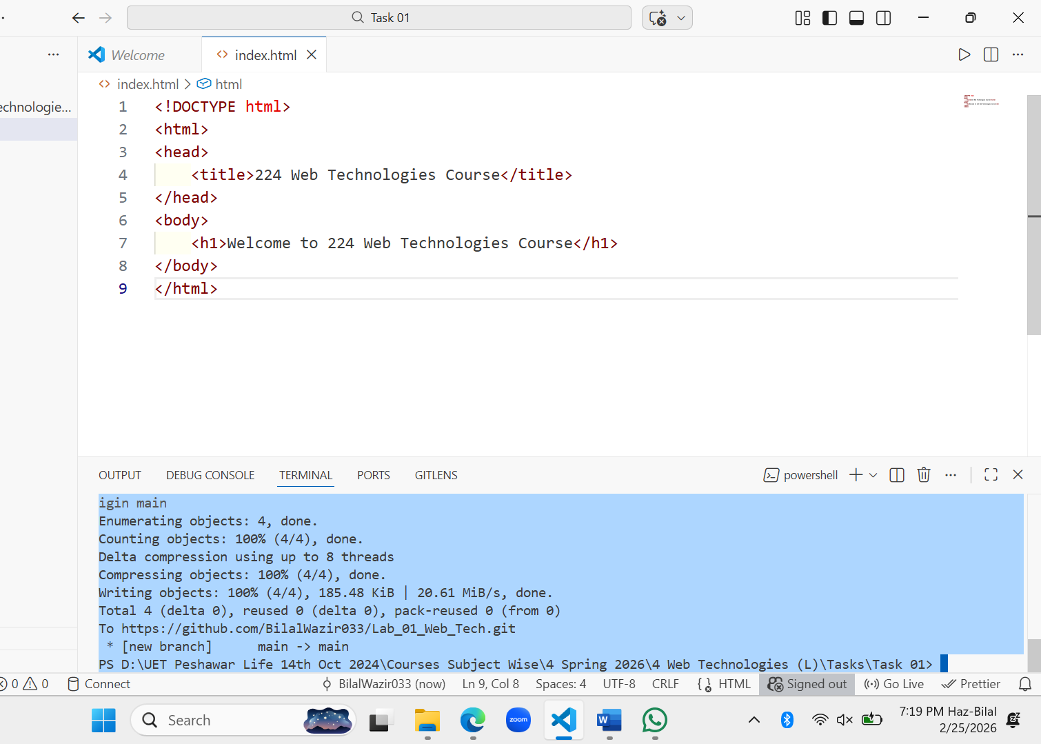

**Task 2: Updating the HTML File with Comments**

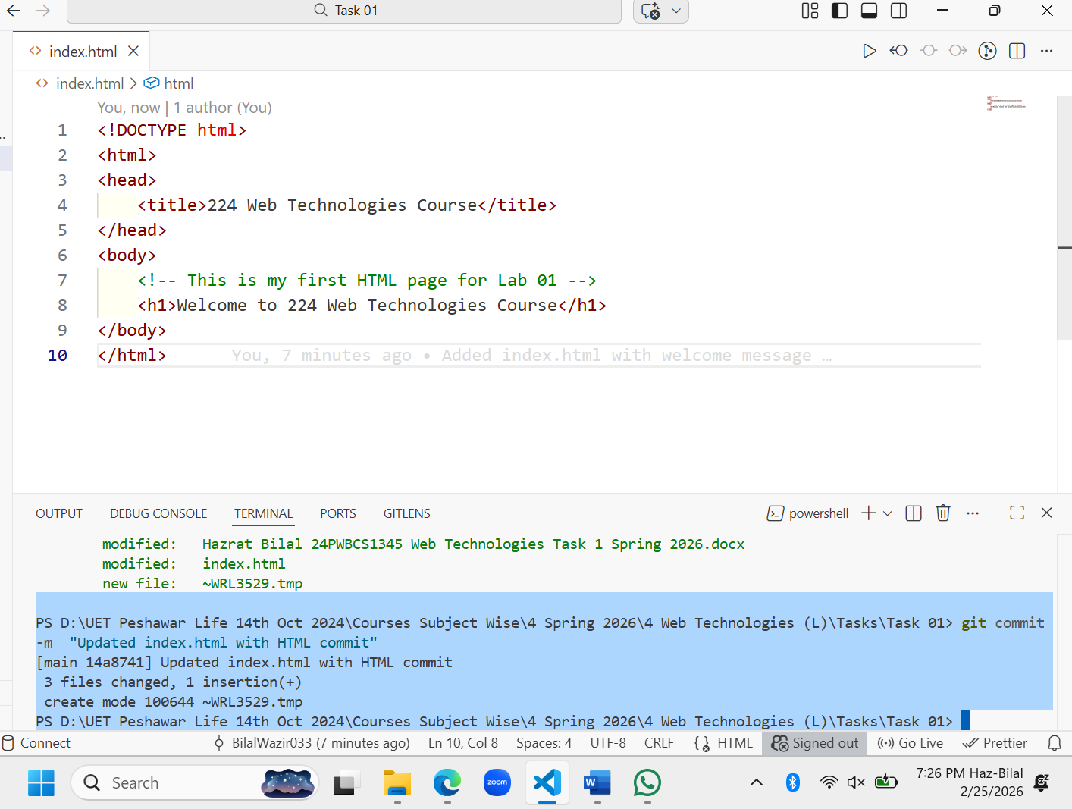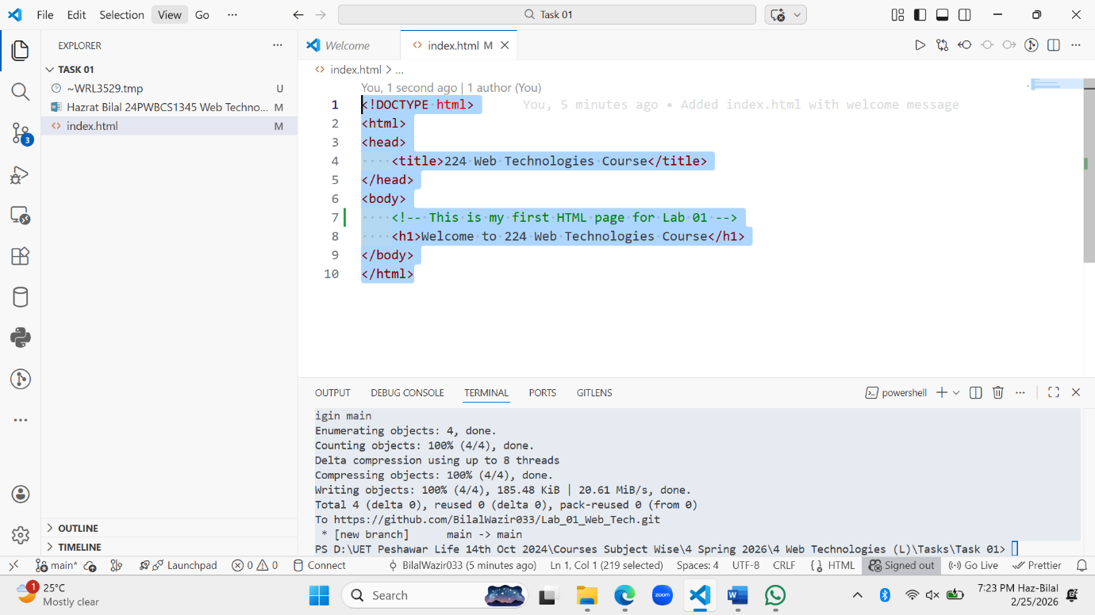

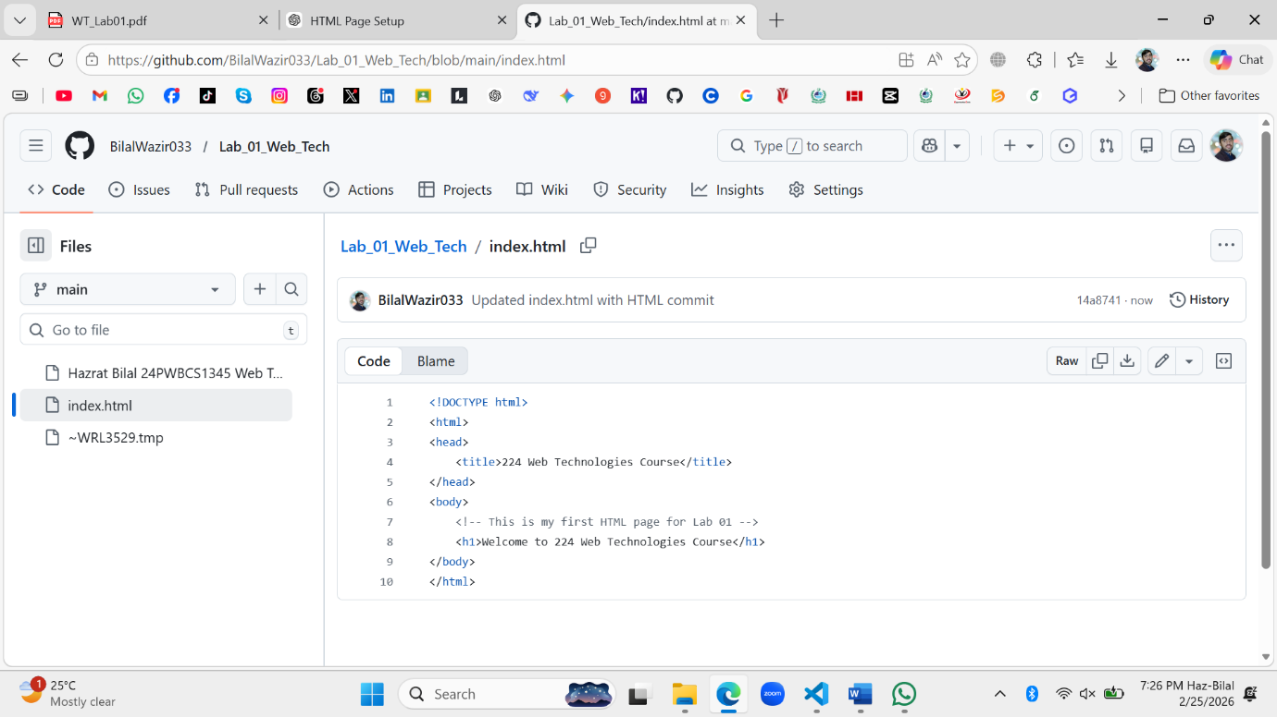

**Task 3 – Creating a .gitignore File**

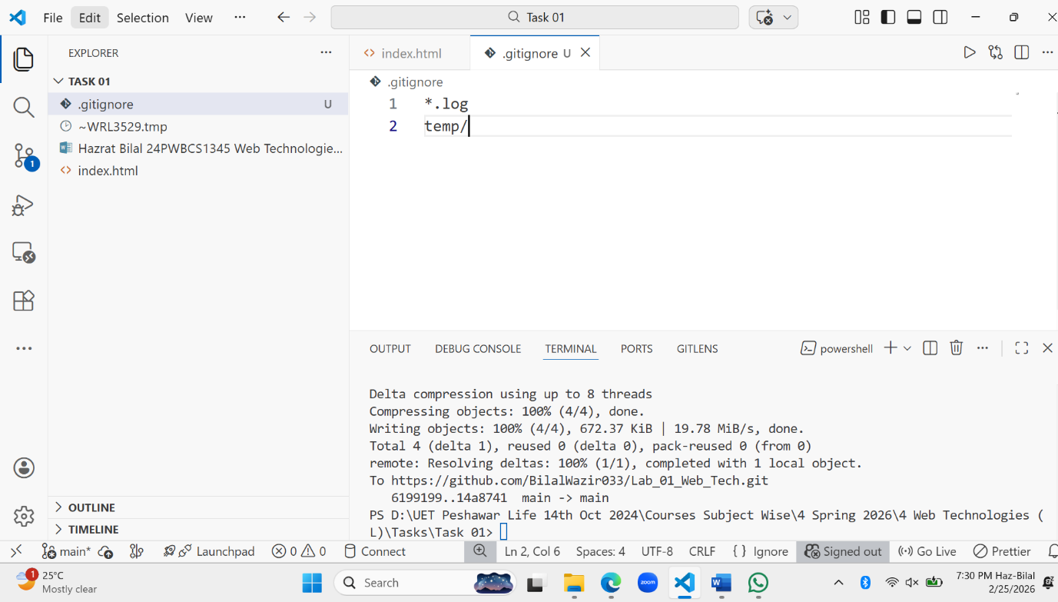

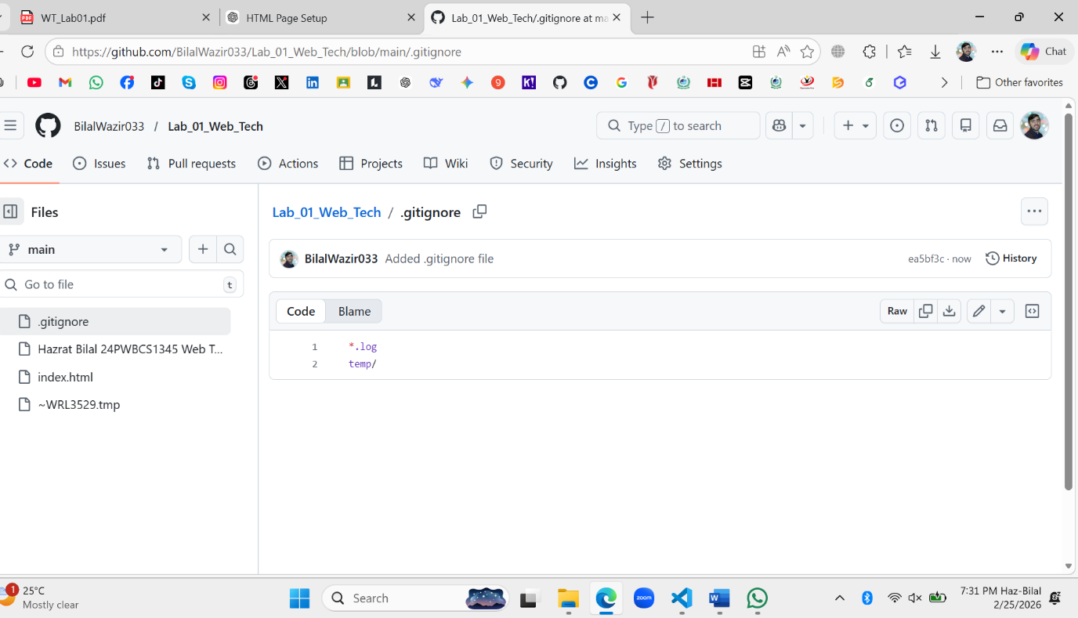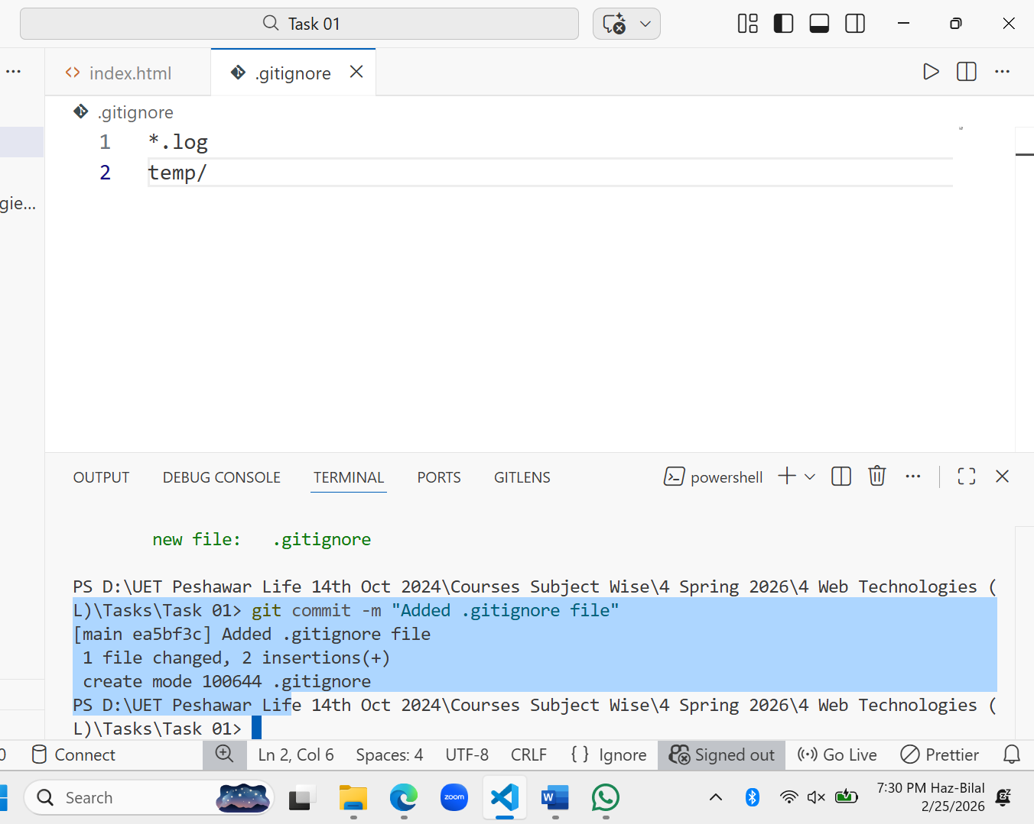

**Task 4 – Adding a License File**

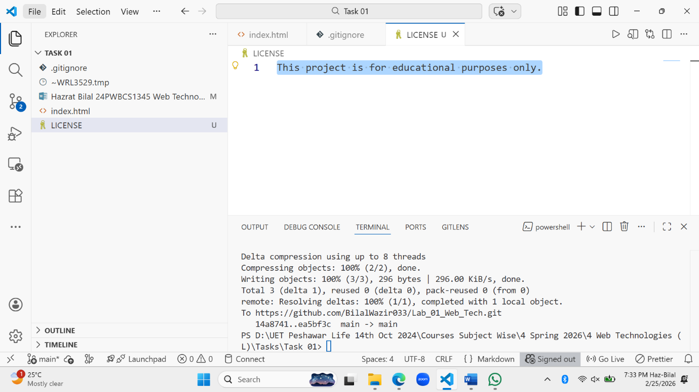

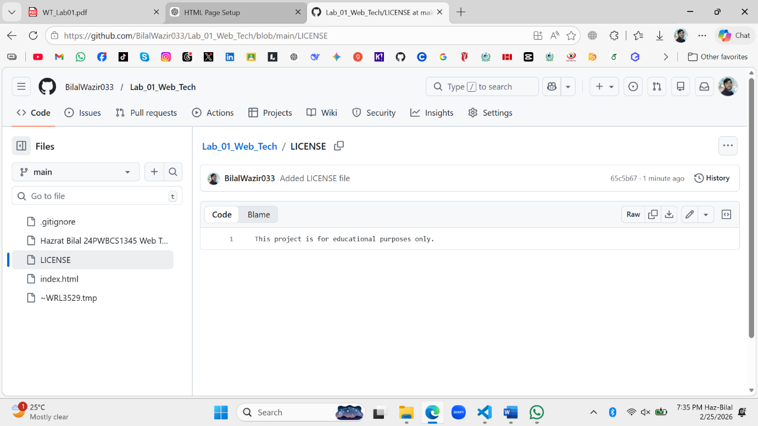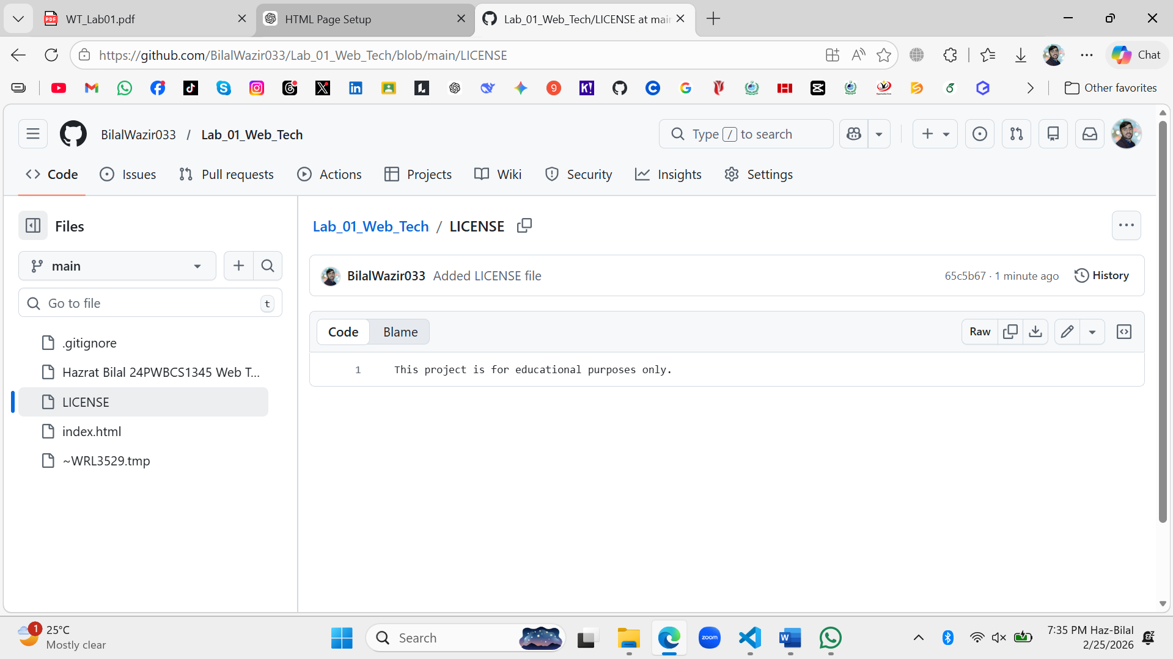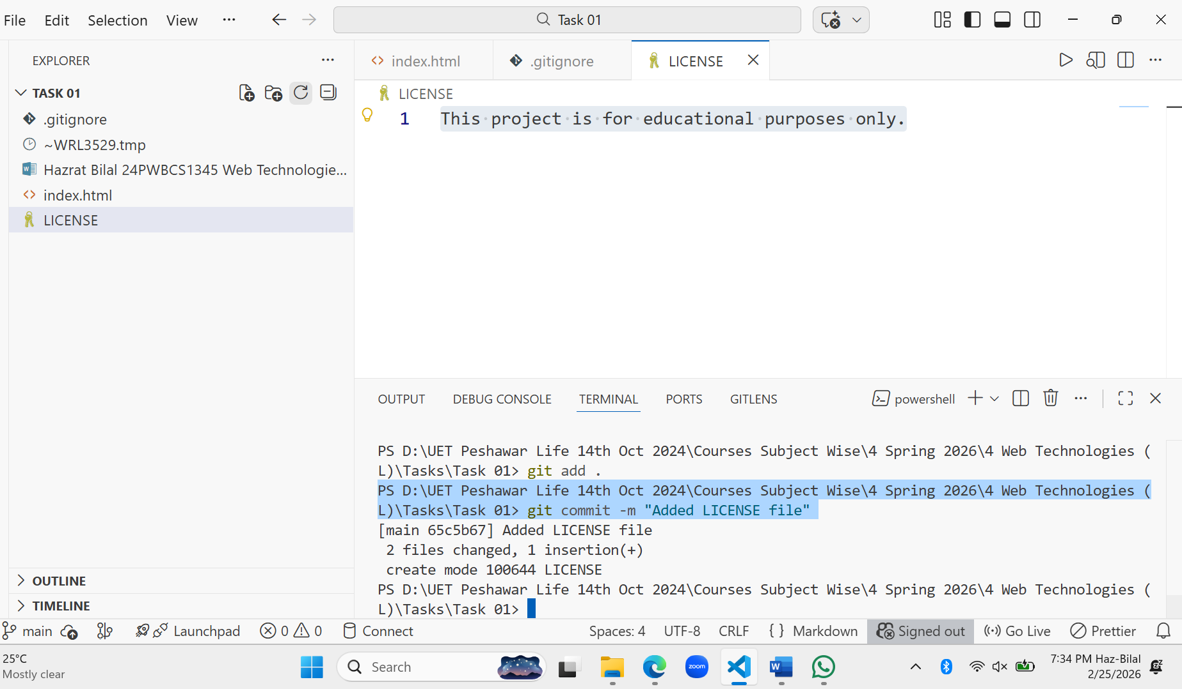

**Task 5 – Creating and Deleting a File**

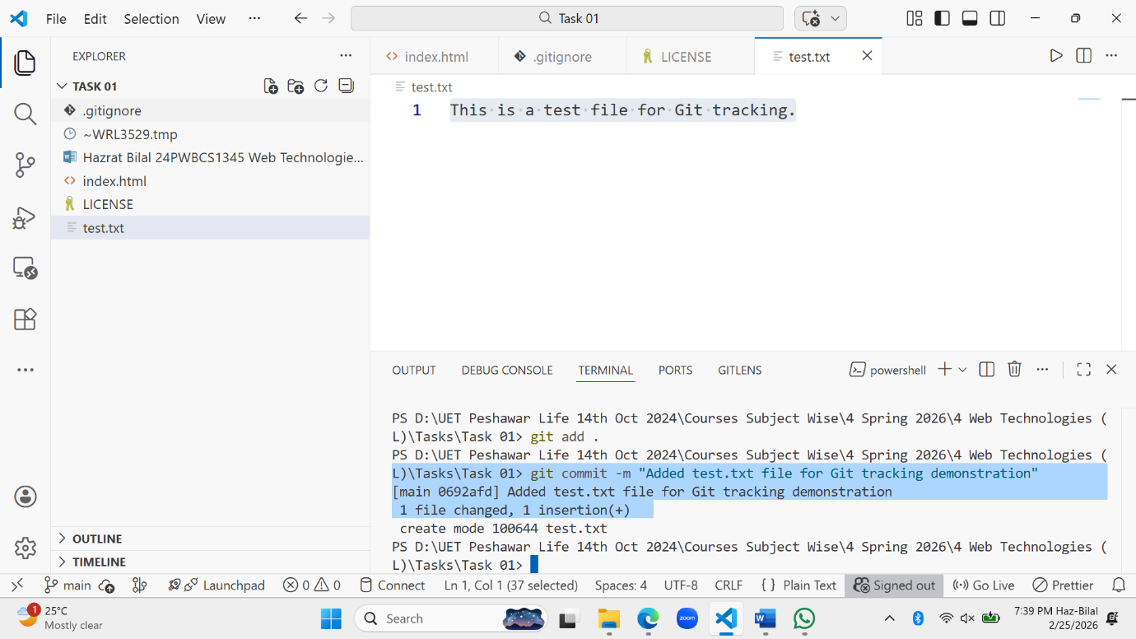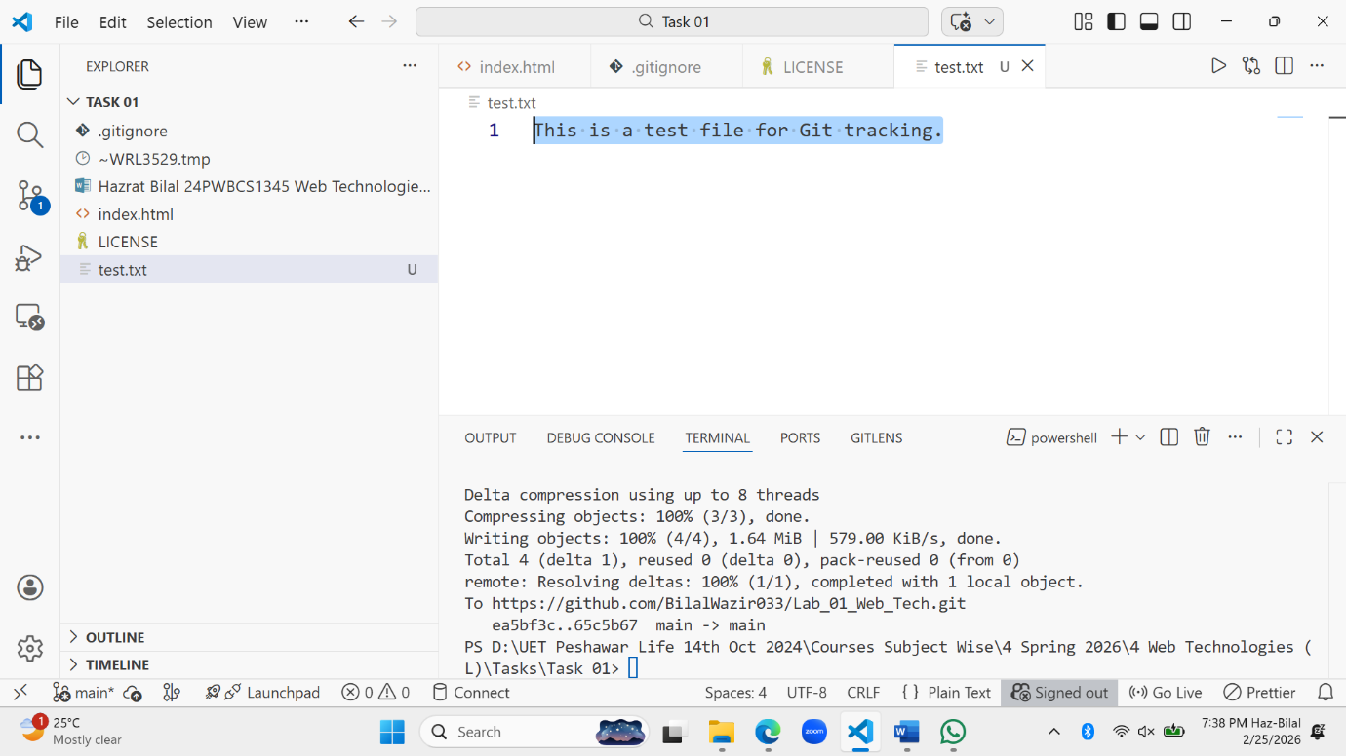

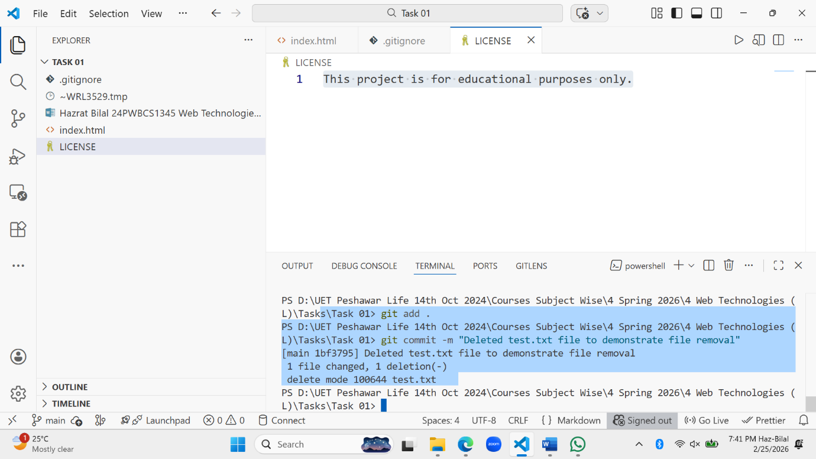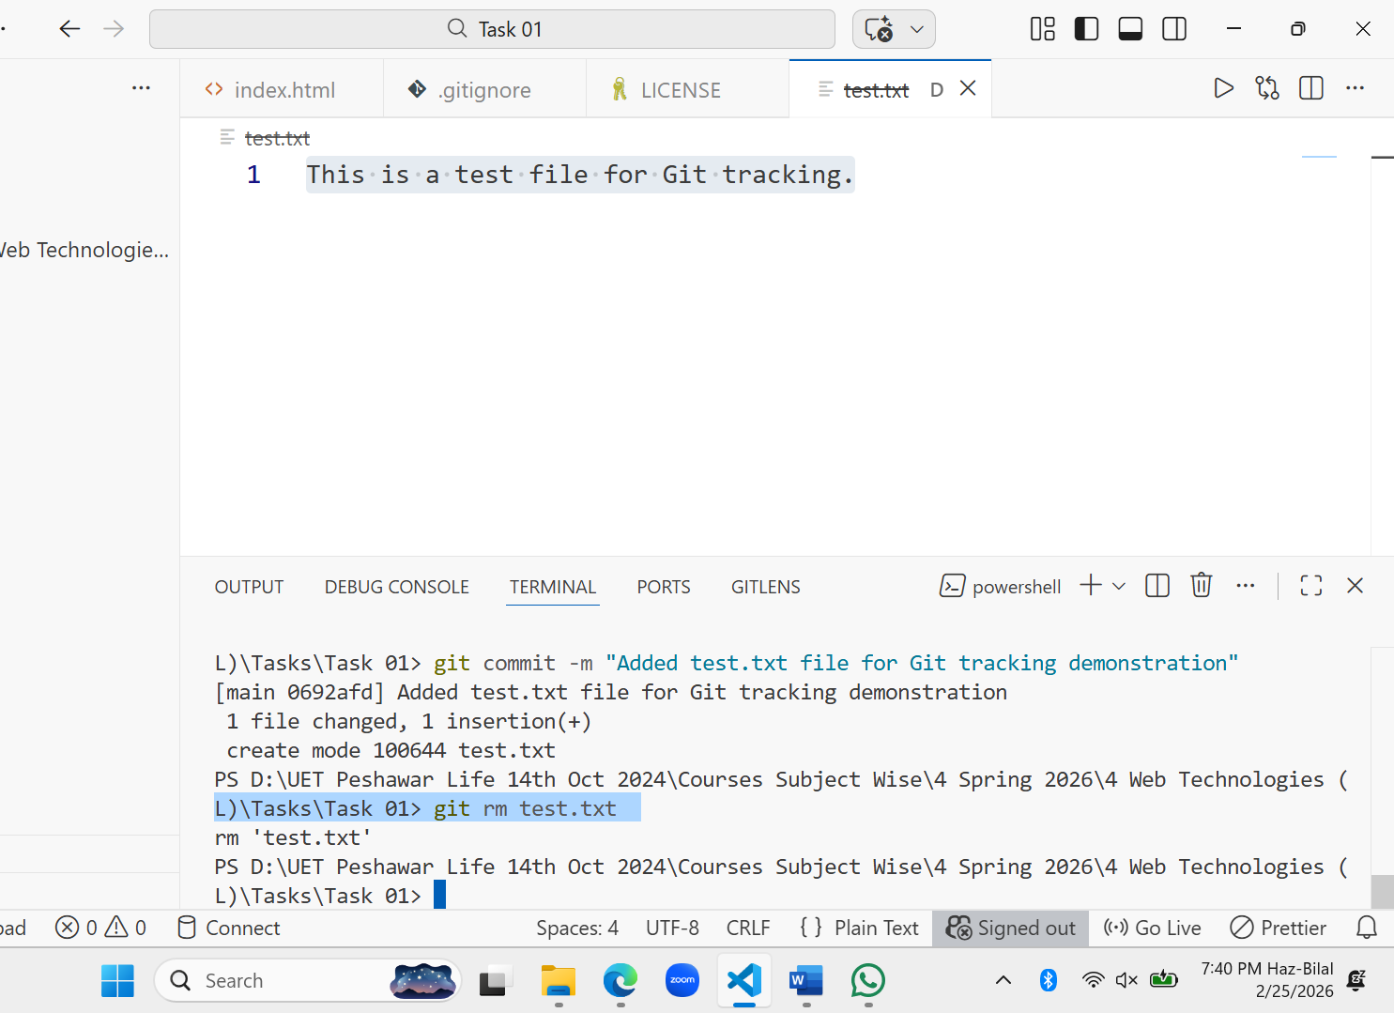

**Task 6 – Working with Branches**

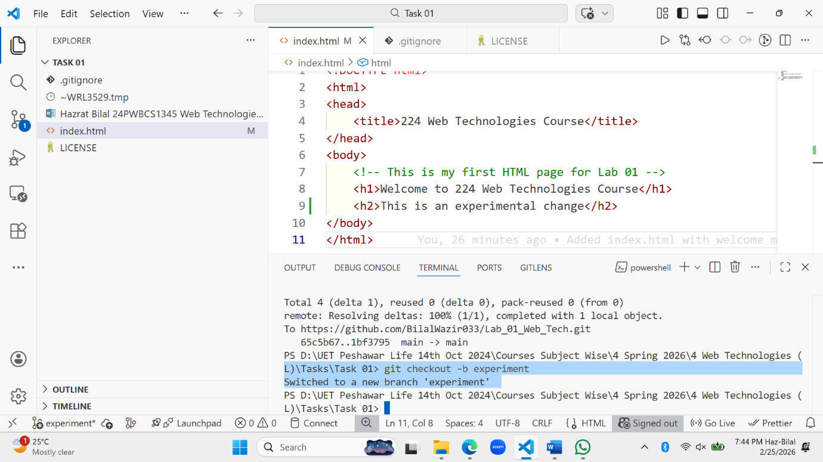

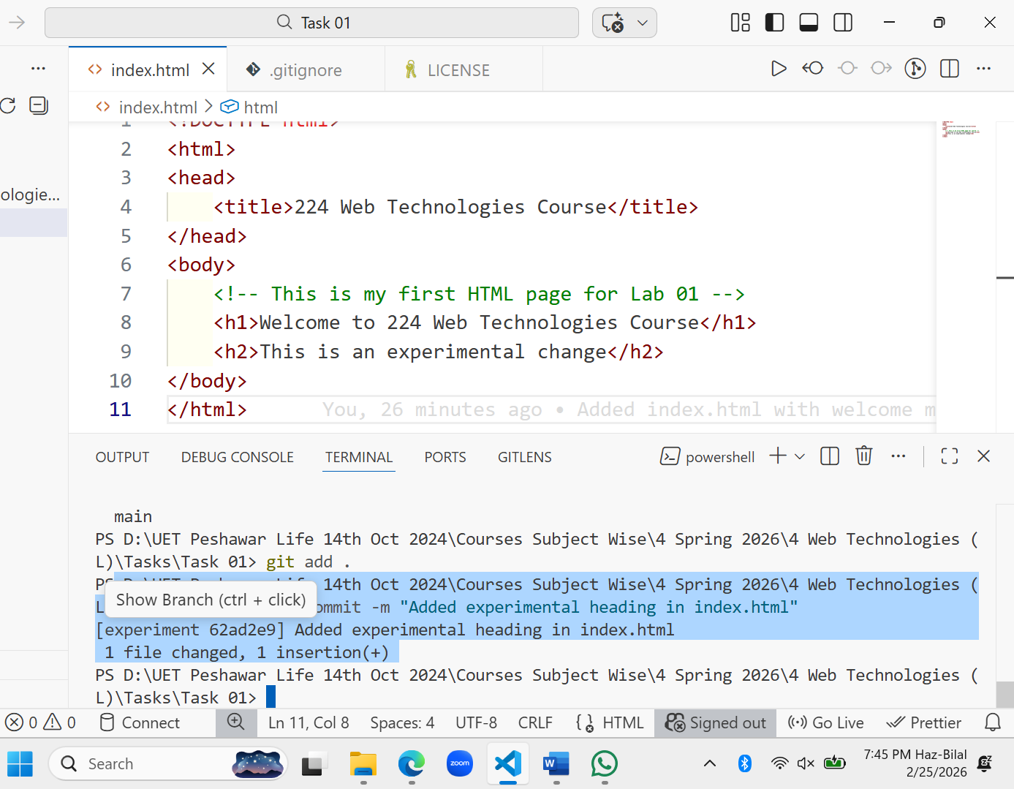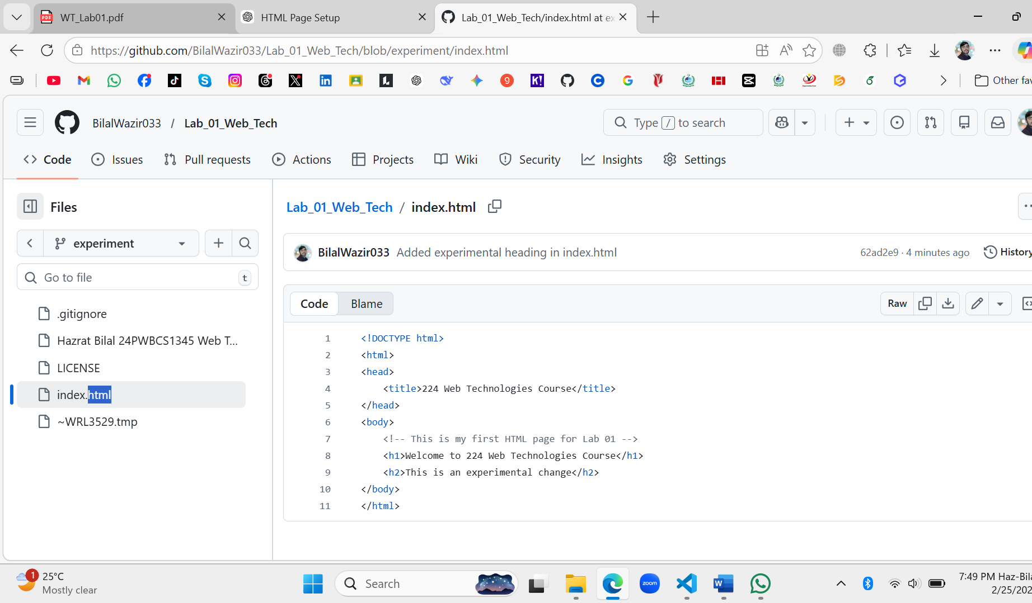

**Task 7 – Merging Branches**

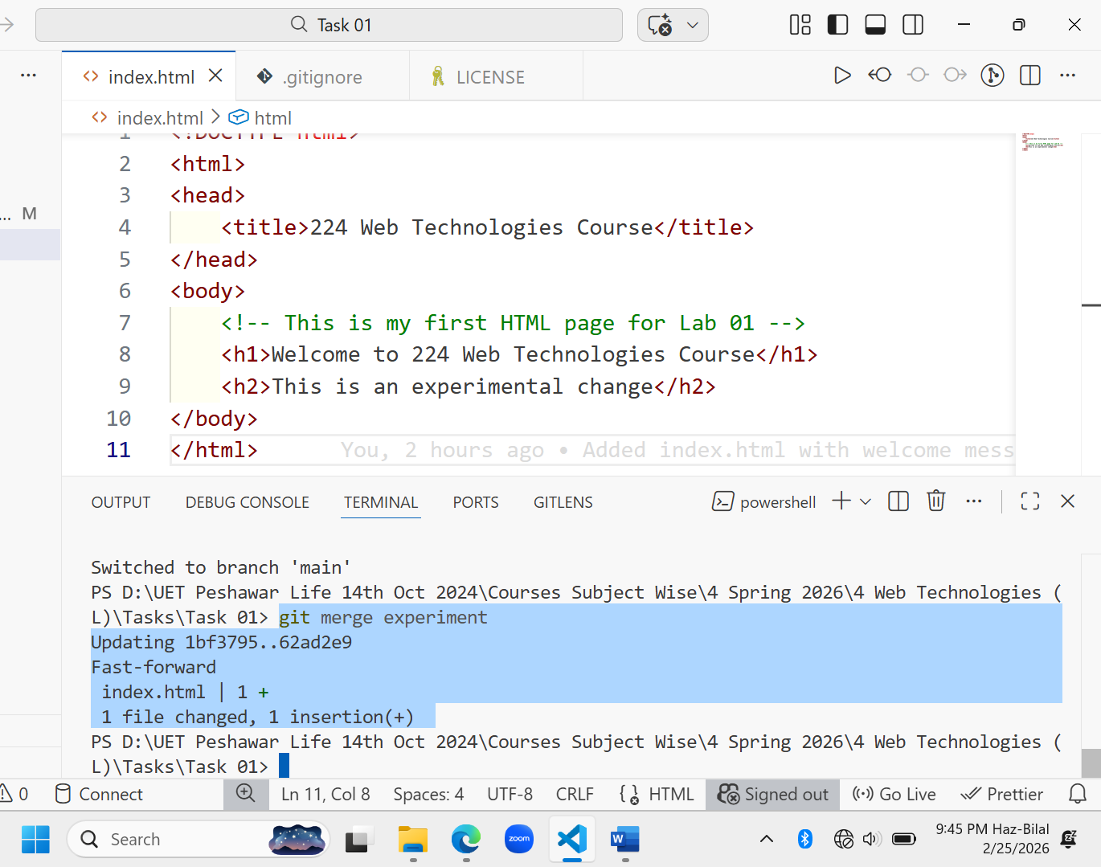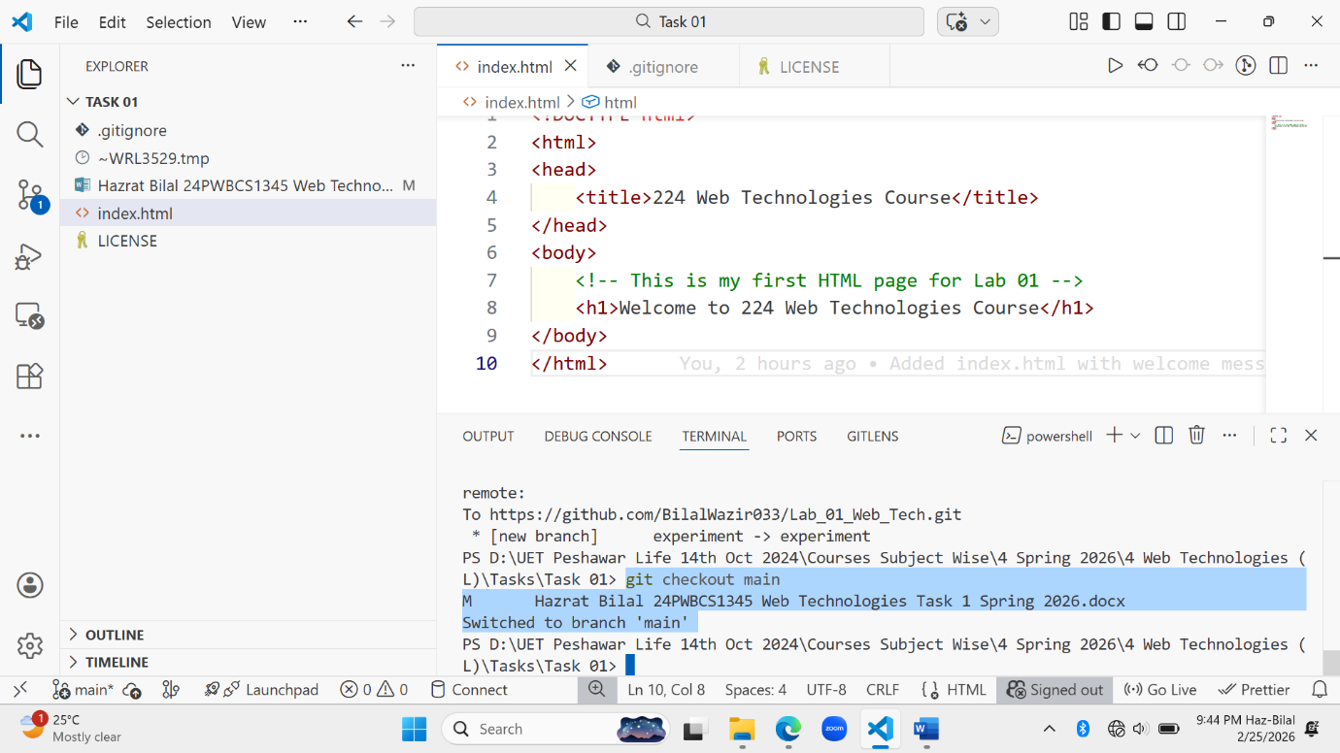

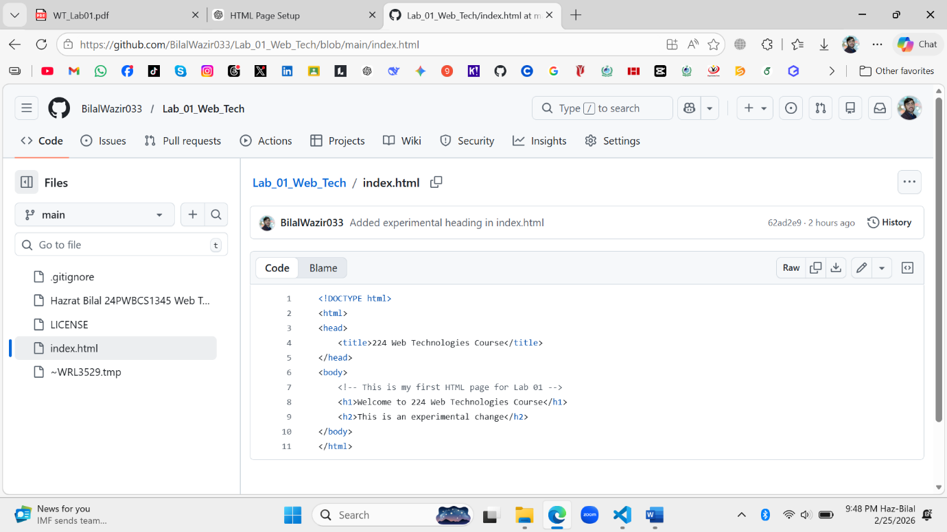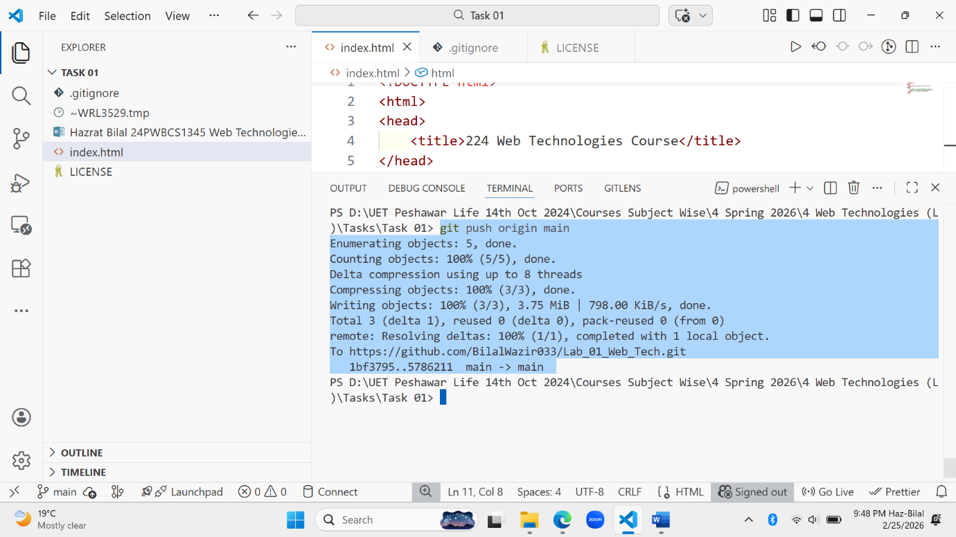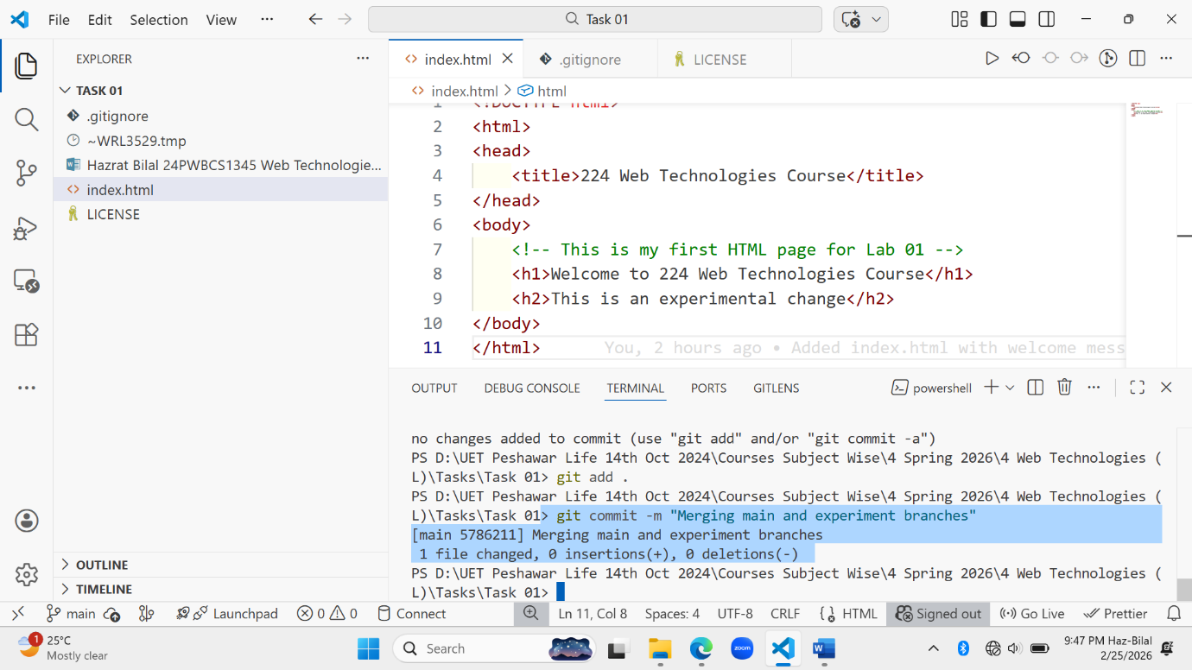

**Task 8 – Writing a Markdown Report**

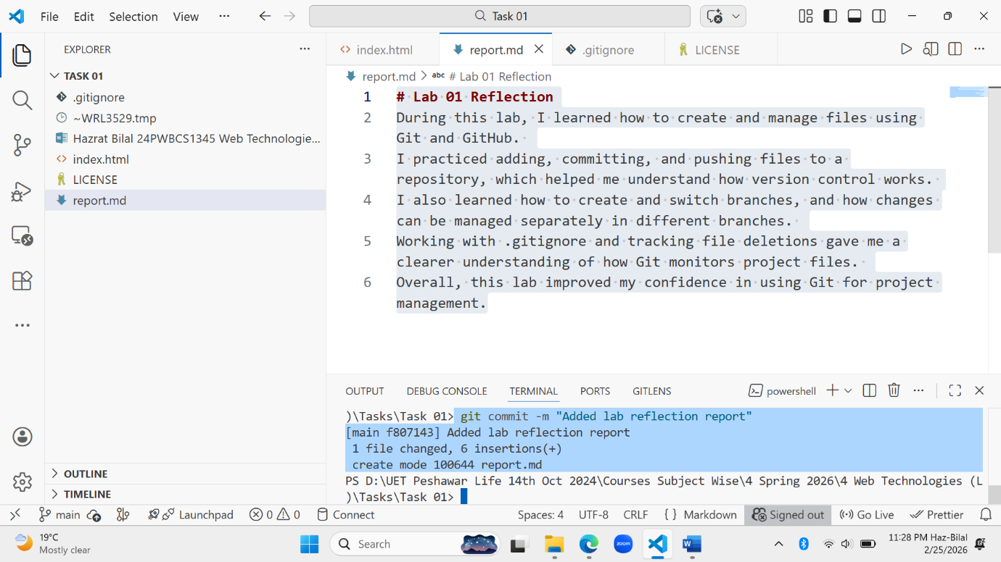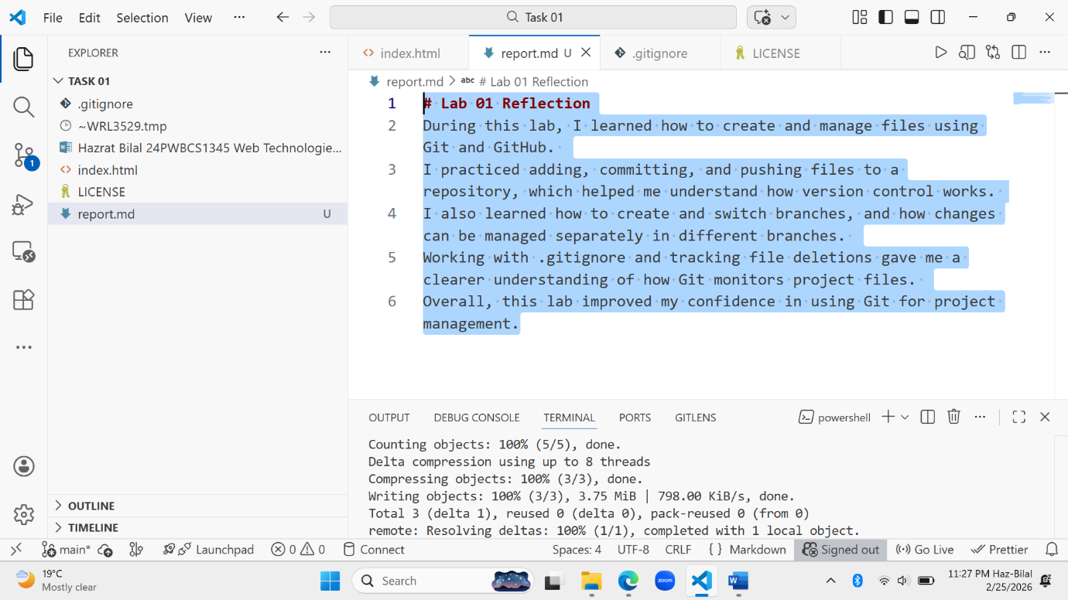

THE END